Score:

**22:544:605 Introduction to Software Development**

**30 points**

*Please turn off your cellphone and write your name in the box on the top of this page.*

*I do* NOT *tolerate cheating*. Students are responsible for understanding the RU Academic Integrity Policy (as listed in the course’s syllabus). I will strongly enforce this policy and pursue *all* violations.

Alternate seating: do not sit next to another student or in your usual seat.

This exam is closed book. You can use your computer to debug but you cannot use it to read or check references. Teamwork is not allowed.

Please make sure your screenshots are clear enough to read.

If not specified in the questions, assume all questions are compiled using Visual Studio 2015 or 2017 Community Edition.

This exam is from 10 am to 12: 50 pm.

Exam Questions:

Fill in the blanks below *(4 points, q1,2, 3, 4, 5, 6 total 3points, q7 1 point)*

1. Class has three access specifiers. They are: __public, private, protected___________________________________
2. What is the major difference between struct and class_ structure is global by default, class is local by default________________________________
3. GUI stands for __Graphical User Interface__________________________________________________
4. OOP stands for __Object-Oriented Programming____________________________________________________
5. We discussed three OOP features, list all three: __encapsulation, _inheritance, polymorphism________________________________________________
6. iostream reduces all errors to one of four states, such as eof(), list other three:

_good, fail, bad_____________________________________________________

1. When should we use call-by-value: for very small objects

When should we use call-by-reference: _ for large objects______________

When should we use call-by-const-reference: _ only when we have to return a result rather than modify an object through a reference argument__________________________

1. Suppose the correct ( ) and wrong ( ) functions are defined as below *(4 points):*

bool correct( ) bool wrong ( )

{ {

return false; return true;

} }

|  |  |
| --- | --- |
| ***Boolean expression*** | ***Value of expression***  ***(Mark x next to true or false)*** |
| wrong ( ) && wrong ( ) | false true x |
| wrong ( ) && correct ( ) | false x true |
| correct ( ) && wrong ( ) | false x true |
| correct ( ) && correct ( ) | false x true |
| !(wrong( ) && (correct( ) || !wrong( ) ) ) | false true x |
| correct()||wrong() | false true x |
| wrong()||correct() | false true x |
| correct()||correct() | false x true |
| wrong()||wrong() | false true x |

1. What do the following *cout* statements print? Each row of the table represents a line of code in the same program, so if *i* changes in one row, you should use that new value in the next row(s) (2points).

int i = 1;

|  |  |
| --- | --- |
| ***Code*** | ***Printed on cout*** |
| cout << ++i; | 2 |
| cout << i++; | 2 |
| cout << “I”; | I |
| cout << (i=-1); | -1 |

Programming section: Please write down your full program below clearly. Screen shot your source code, running program, input/output if any. When a header file is specified, please use the specified header. If no header file is specified, use any one that would work with your programs. *(20 points total. 5 points each)*

1. **Using our class header files** to write a program that a) create an 1024 by 768 window and name it “ISD_2024_SPRING”. b) Attaches a black dash line triangle to the canvas. c) Fills the triangle in blue color. d) Attaches a black solid line rectangle to the canvas. e) Fills the rectangle in black color. (Note: image below is for reference only. Follow the instruction above.)

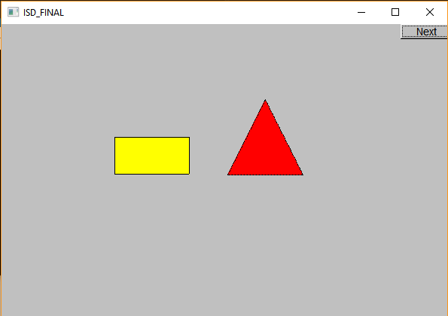

1. **Class interface:**

Implement a class and name it ISDFinal. Put your class definitions and function prototypes in a header file called ISDFinal.h, and your function definitions in a file called ISDFinal.cpp. Do not add any other features.

1 Foundation

Create the class with two private ints. Name them x and y.

2 Constructors

Implement a single constructor that, if called with 0 arguments, initializes a point to the origin – (0, 0) – but if called with two arguments x and y, creates a point located at (x,y). (Hint: You will need to use default arguments.)

3 Member Functions

Support the following operations using the given function signatures:

•Get the x coordinate

int ISDFinal::getX() const

• Get the y coordinate

int ISDFinal::getY() const

• Set the x coordinate

void ISDFinal::setX(const int newx)

• Set the y coordinate

void ISDFinal::setY(const int newy)

4 Write a program in a file called source.cpp, which 1) uses the class and the header file you defined above. 2) declares a ISDFinal type named ISDSP. 3) displays initial values. 4) asks user to type in values for x and y. 5) display the updated x and y values. Do not add any other feature or function.

Draw a UML diagram of this class.

Screenshots of your ISDFinal.h , ISDFinal. cpp, source.cpp and running program below:

Blank page for previous question. One more page behind!

1. **Using IO stream or fstream and string** library to write a program that a) download the two txt files b) ask the user to type in a file name and load the file. Reads in file1.txt c) ***gives error message*** when file cannot be opened. d) ***outputs the total number of characters and total number of lines*** in the file the program reads, to a ***file named springISD2024.txt***. d) in springISD2024.txt**, structure the outputs so that count of characters and number of lines are separated by tabs**. e) run the program again, now open file2.txt and new counting numbers will be added to springISD2024.txt . Do not add any other feature or function.

Screenshots of your source code, running program, input files and output file (twice).

1. **Using IO stream** library to write a program that a) create an int array of eight elements that holds the following values {6,5,3,4,1,2,9,7}. b) write a function to display the values in the array. c) write a function that uses bubble sort algorithm to sort the values in ascending order. d) display the sorted array.  
   Screenshots of your source code, running program, input files and output file.

